# Python Task 2

## Question 2: Car Type Count Calculation

import pandas as pd

def get_type_count(dataset):

# Add a new categorical column 'car_type' based on values of the column 'car'

conditions = [

(dataset['car'] <= 15),

(dataset['car'] > 15) & (dataset['car'] <= 25),

(dataset['car'] > 25)

]

choices = ['low', 'medium', 'high']

dataset['car_type'] = np.select(conditions, choices, default='Unknown')

# Calculate the count of occurrences for each 'car_type' category

type_counts = dataset['car_type'].value_counts().to_dict()

# Sort the dictionary alphabetically based on keys

type_counts = dict(sorted(type_counts.items()))

return type_counts

# Example usage:

# Load the dataset from the CSV file

dataset = pd.read_csv('dataset-1.csv')

# Call the function and print the result

result = get_type_count(dataset)

print(result)

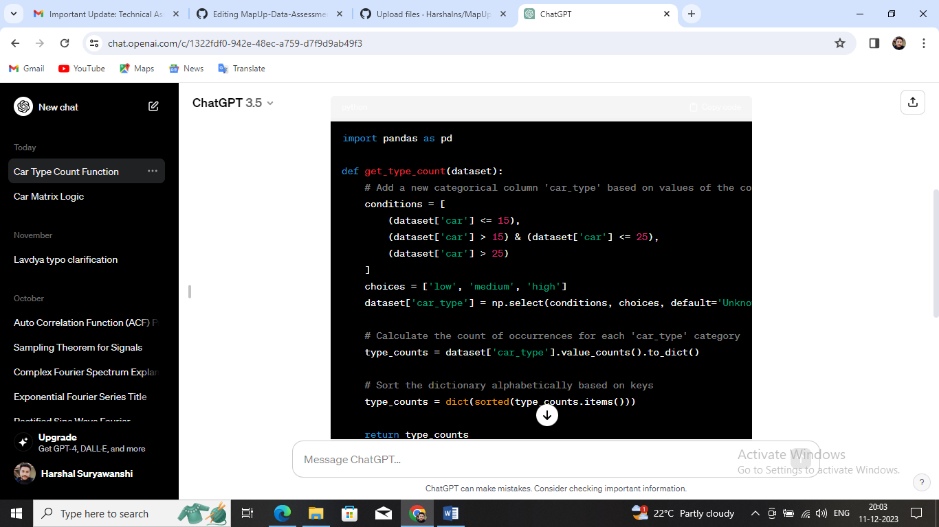Top of Form

